EECS 442 HW2

1.Discuss the differences between the four different integration methods

a Subject I choose: yaleB01

Column method: Row method:

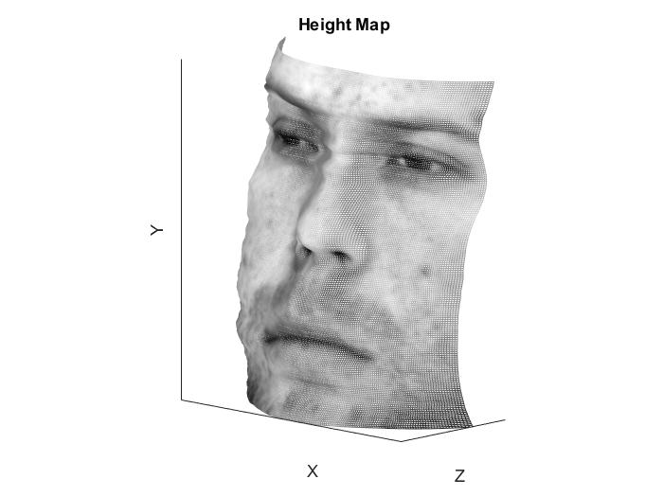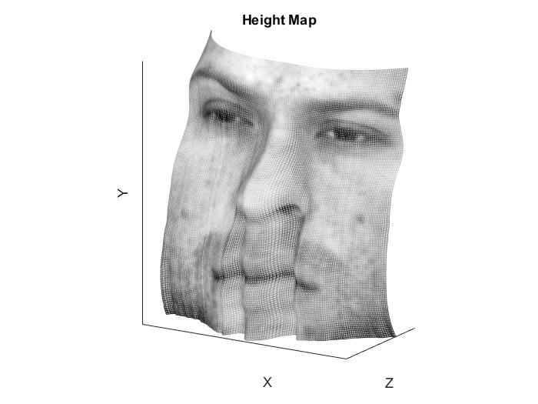

Average Method: Random method:

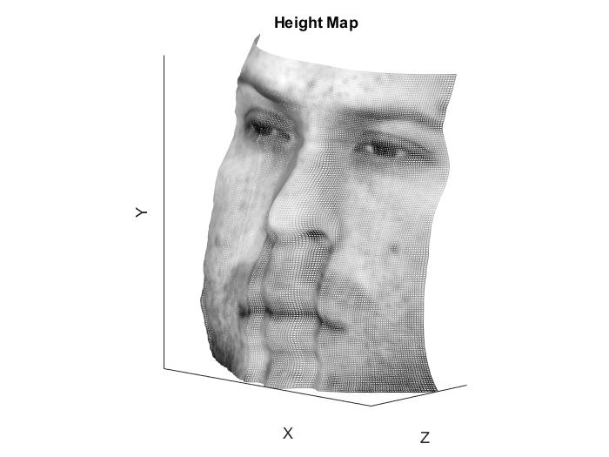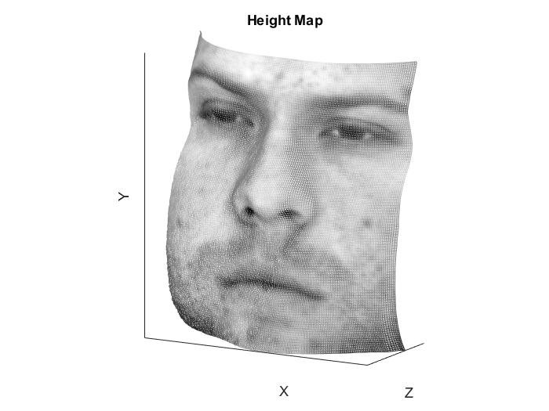

b. Bunning time comparison:

column method: 0.001402s

row method: 0.000800s

average method: 0.004520s

random method: 56.651472s

2. Subject: yaleB01

Column method: 0.001402s Row method: 0.000800s



Average Method: 0.004520s Random method: 56.651472s



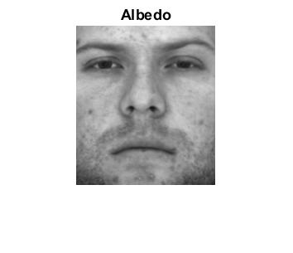Albedo:

Comparison of the heightmap:

Column method:

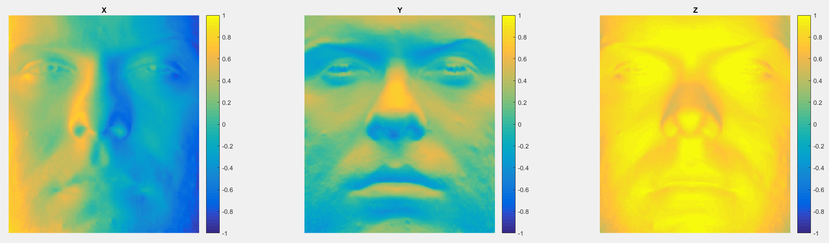

Row method:

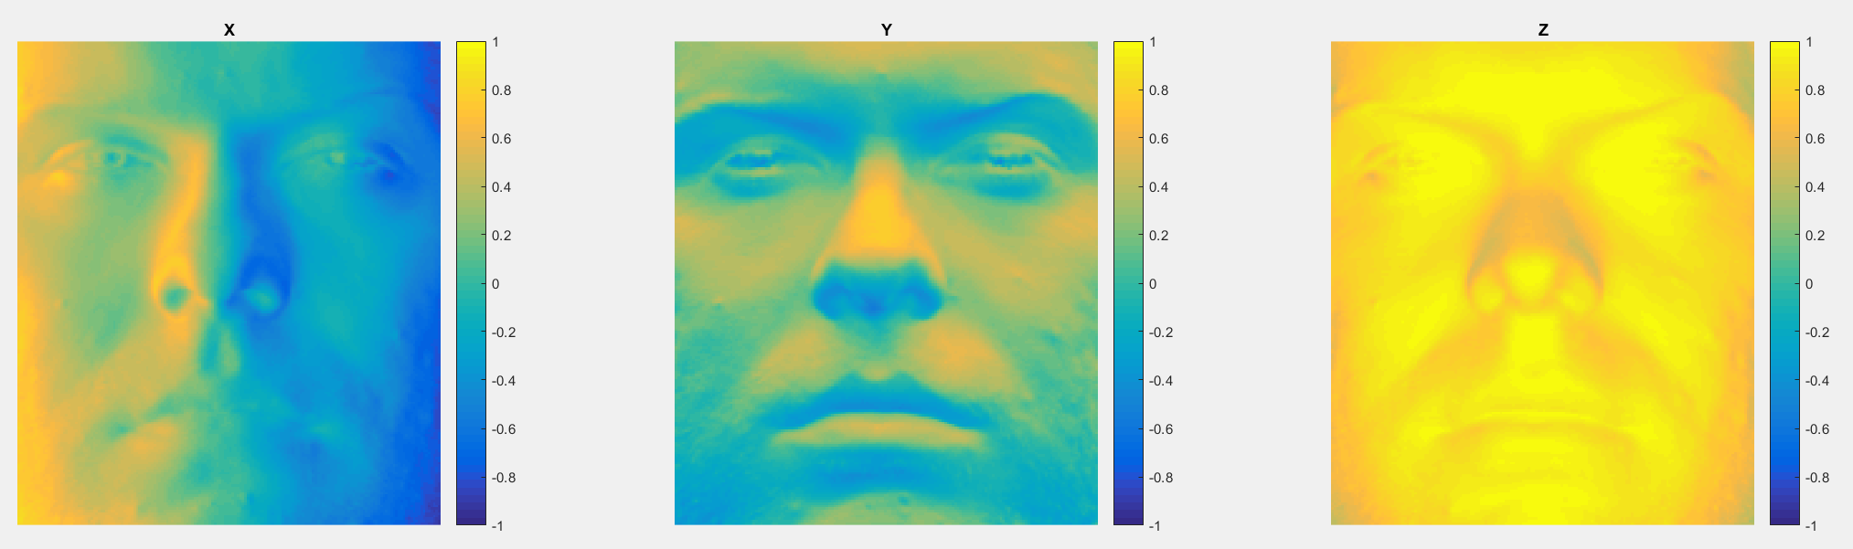

Average method:

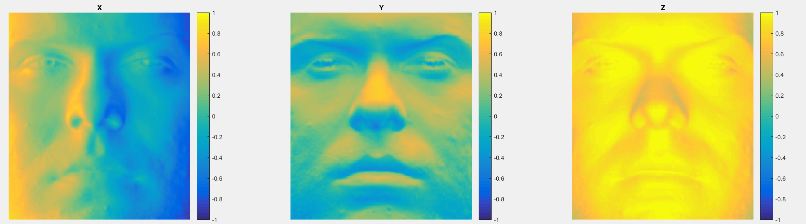

Random method:

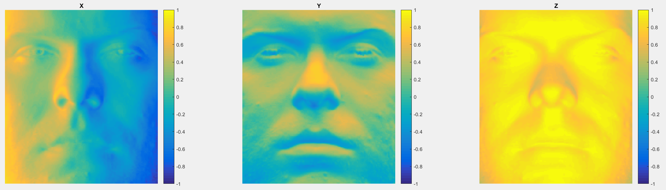

Subject: yaleB02

Column method: 0.004539s Row method: 0.009374s

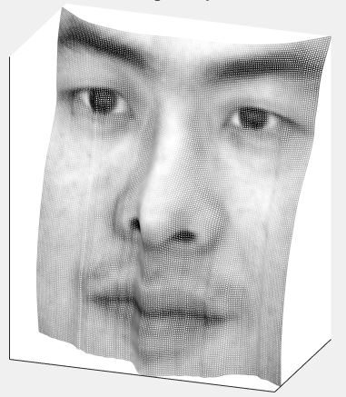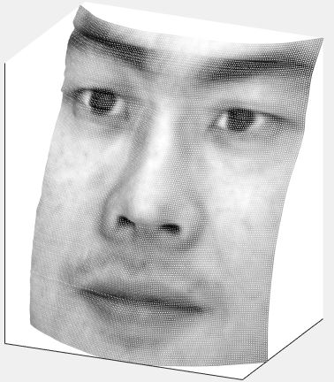

Average Method: 0.006696s Random method: 60.639696s

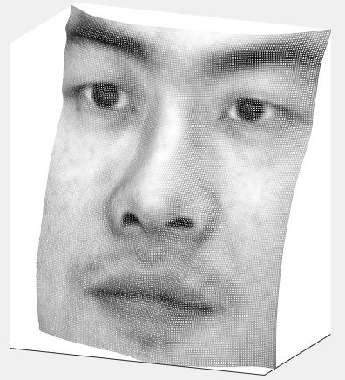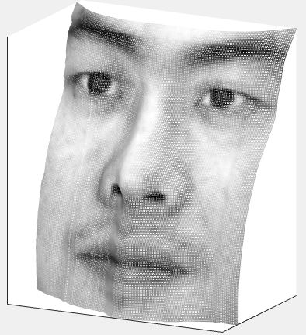

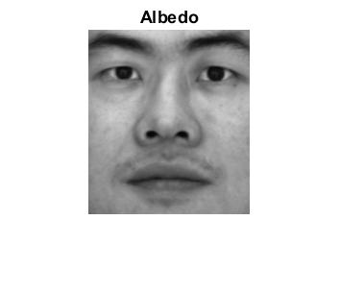Albedo:

Comparison of the heightmap:

Column method:

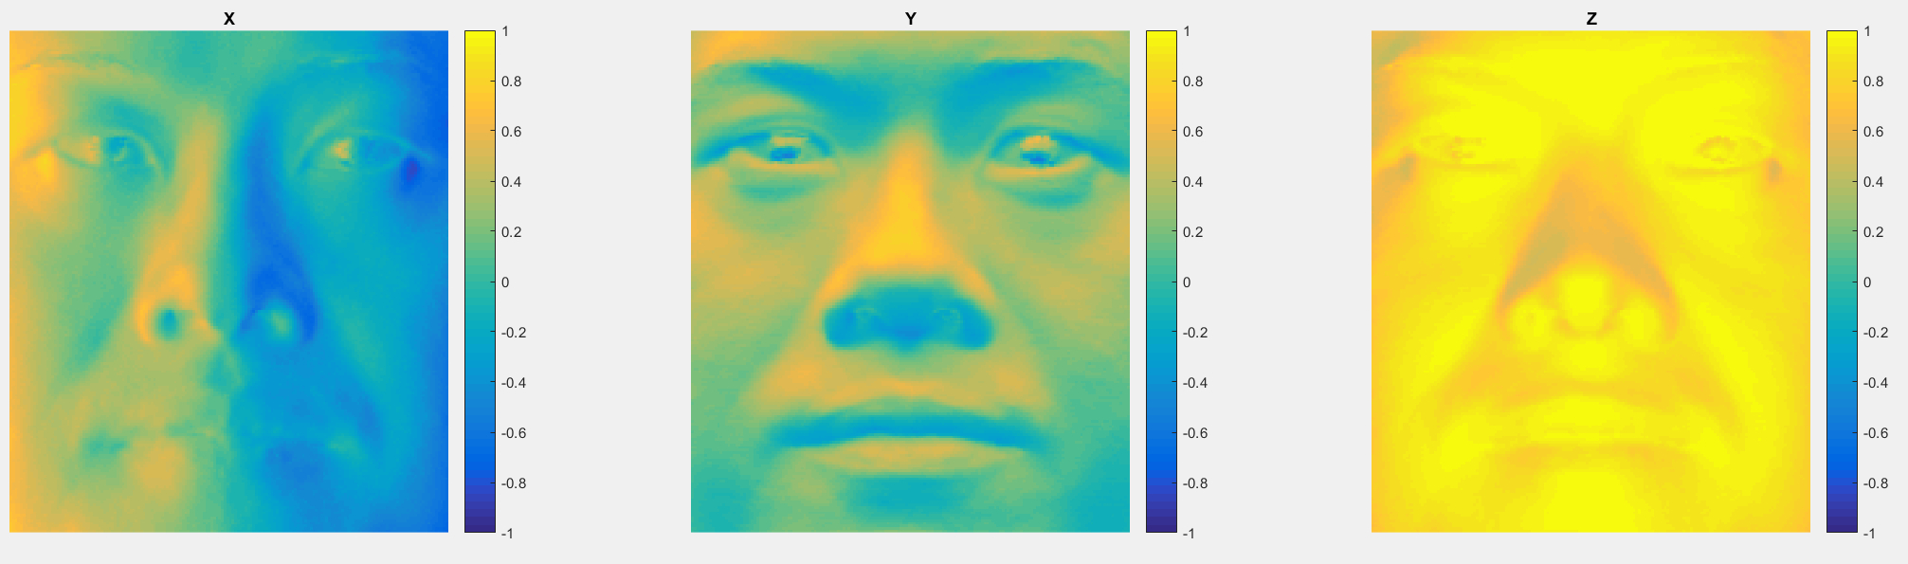

Row method:

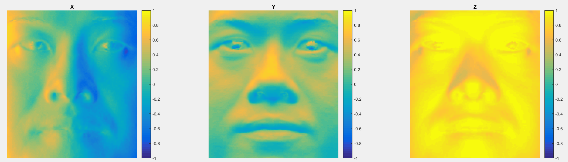

Average method:

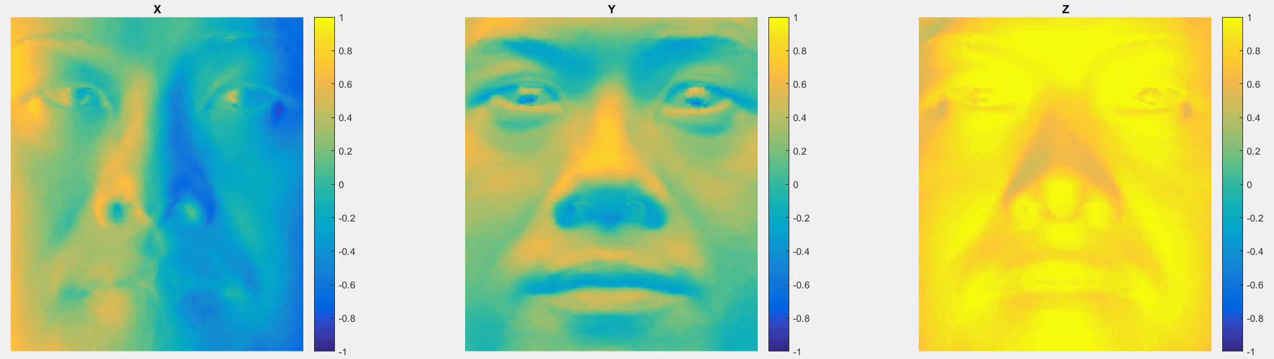

Random method: 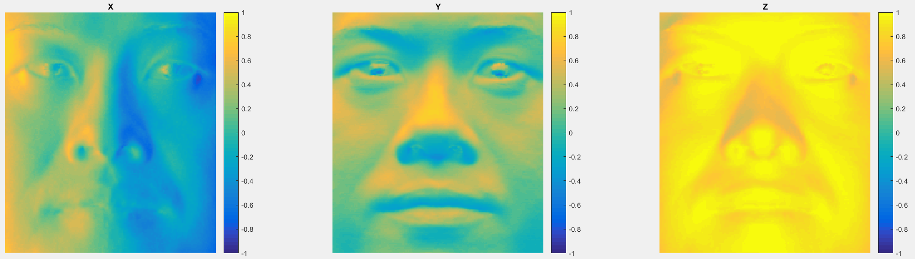Subject: yaleB05

Column method: 0.005643s Row method: 0.004946s

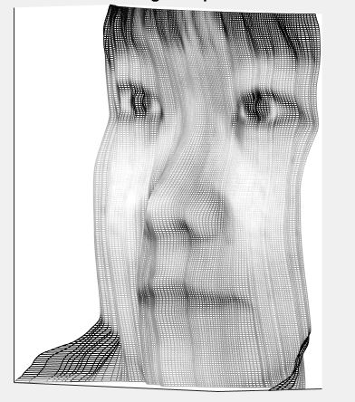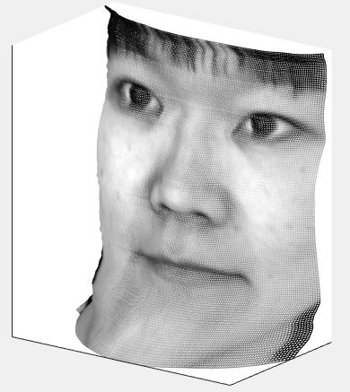

Average Method: 0.007646s Random method: 60.451948s

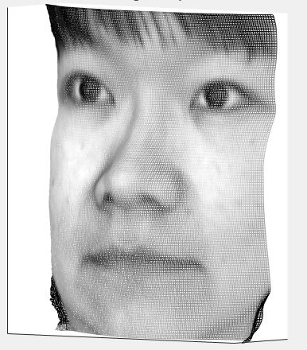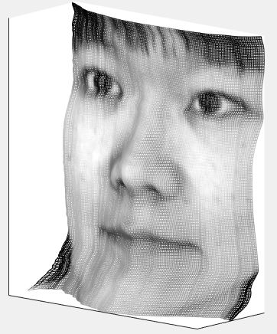

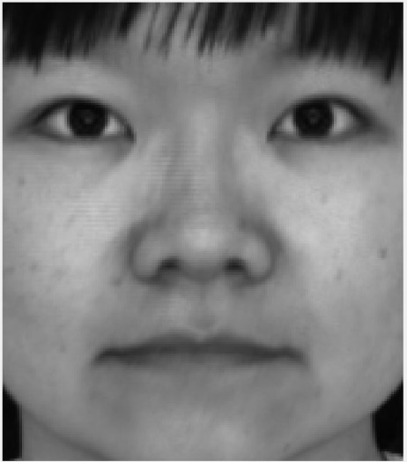Albedo:

Comparison of the heightmap:

Column method:

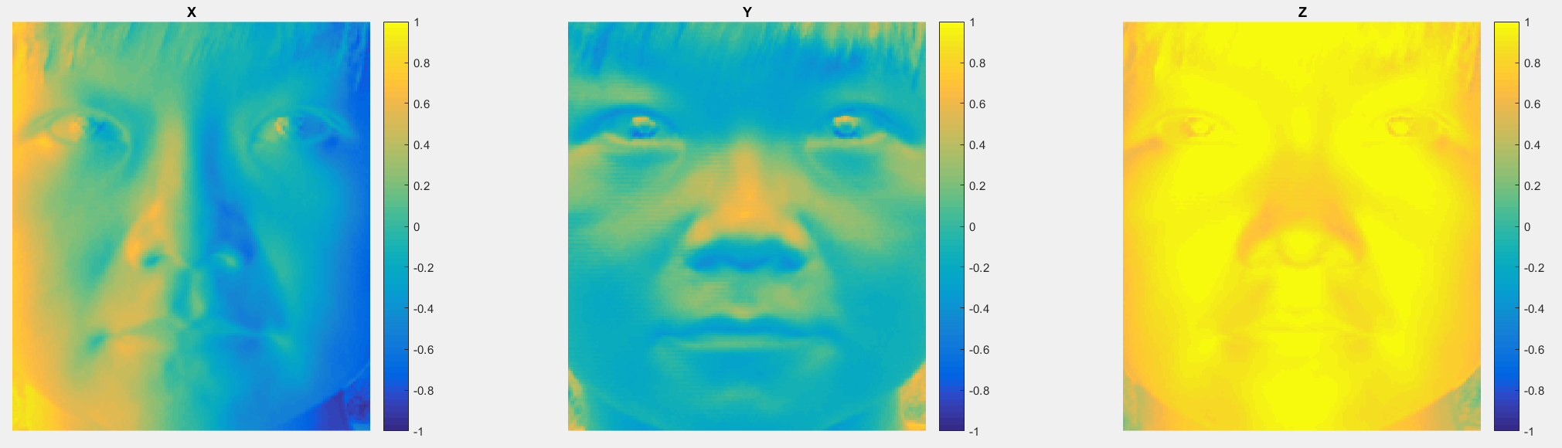

Row method:

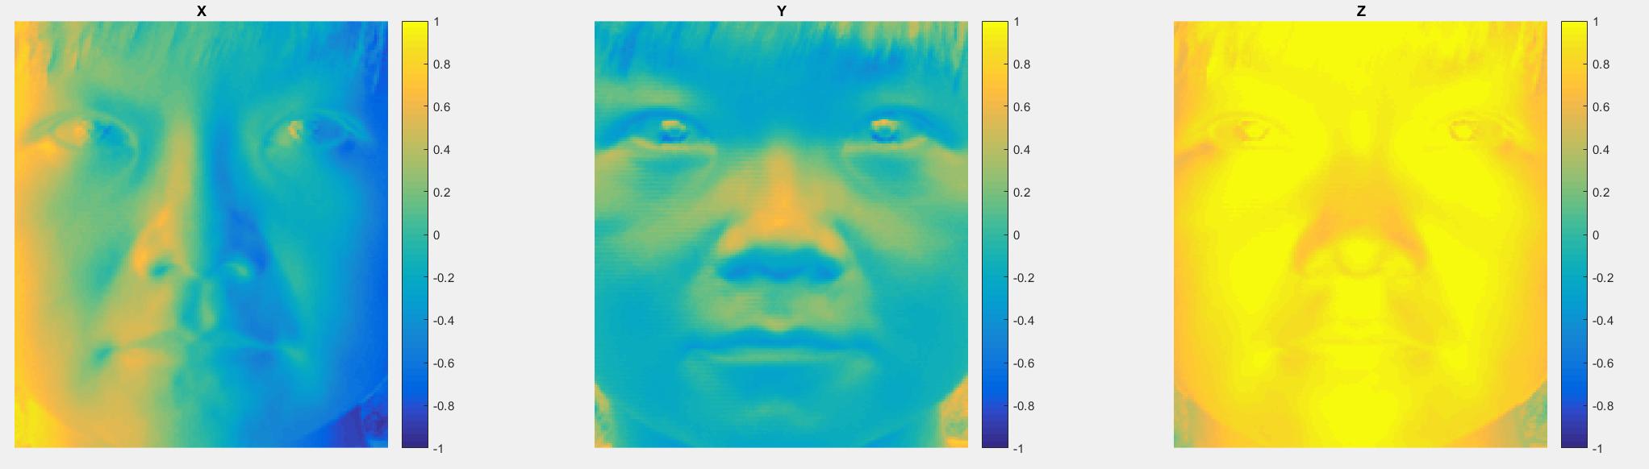

Average method:

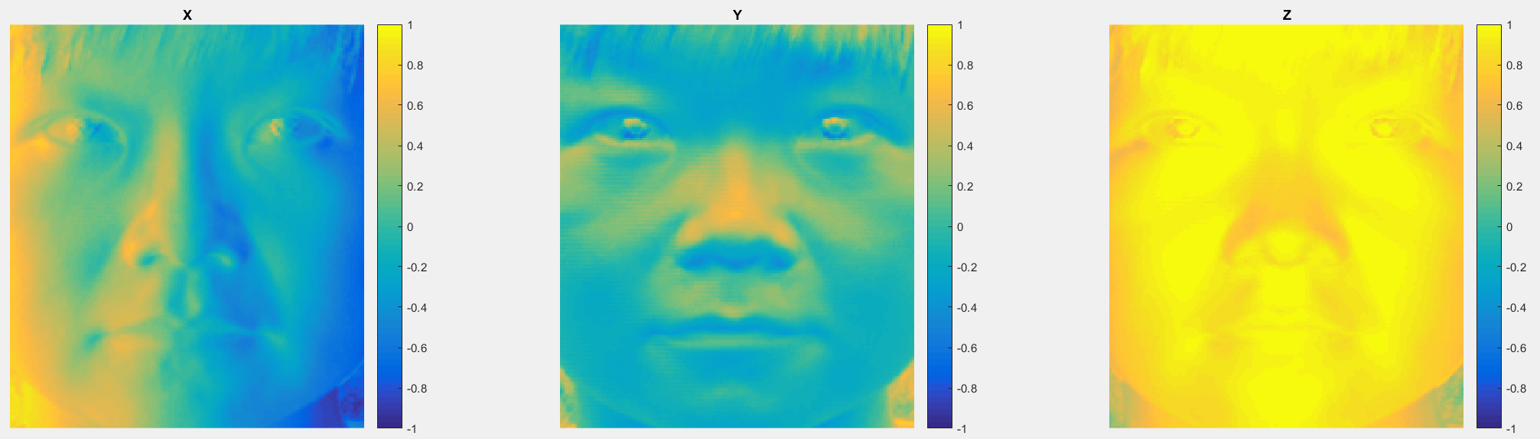

Random method:

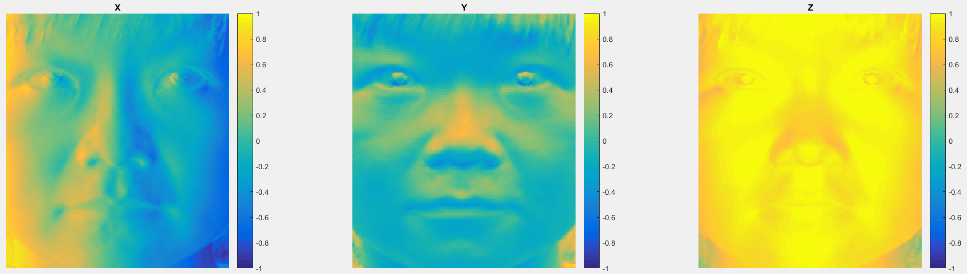

Subject: yaleB07

Column method: 0.006909s Row method: 0.006596s

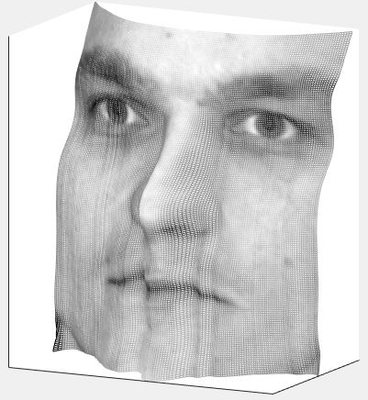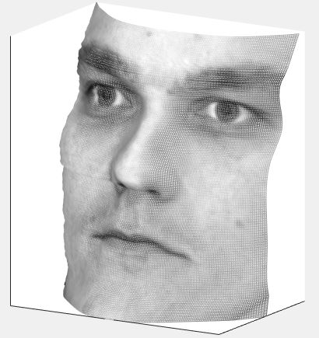

Average Method: 0.005047s Random method: 60.570412s

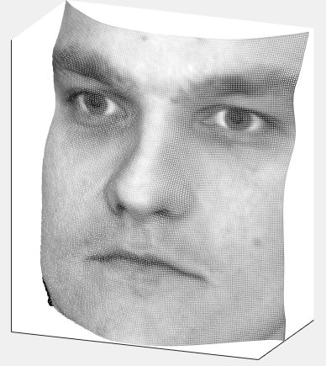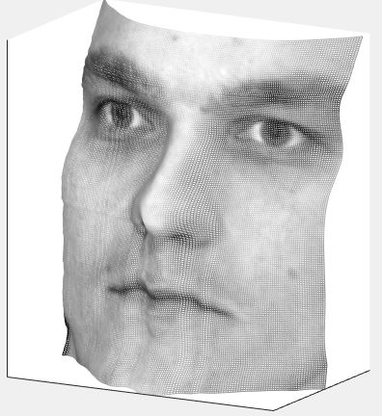

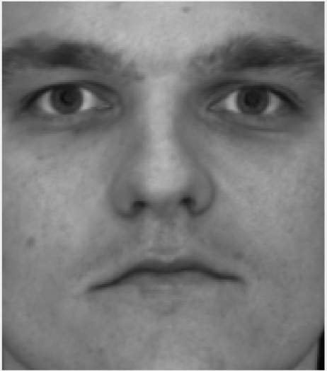Albedo:

Comparison of the heightmap:

Column method:

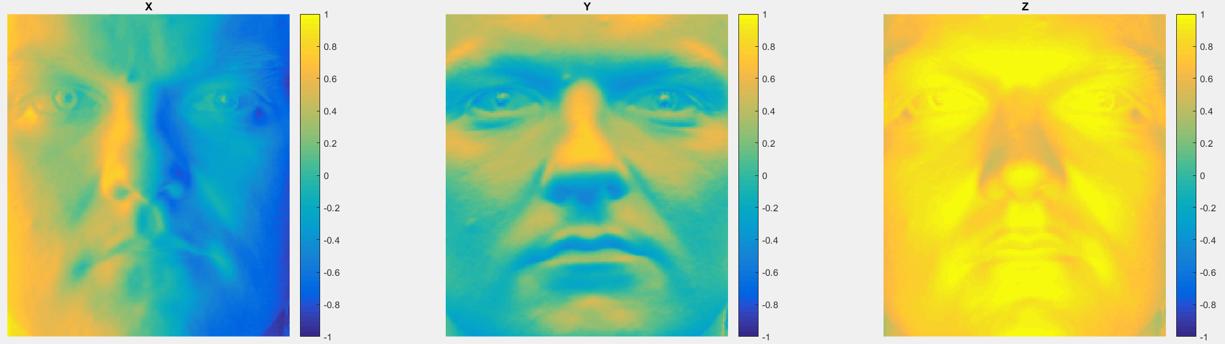

Row method:

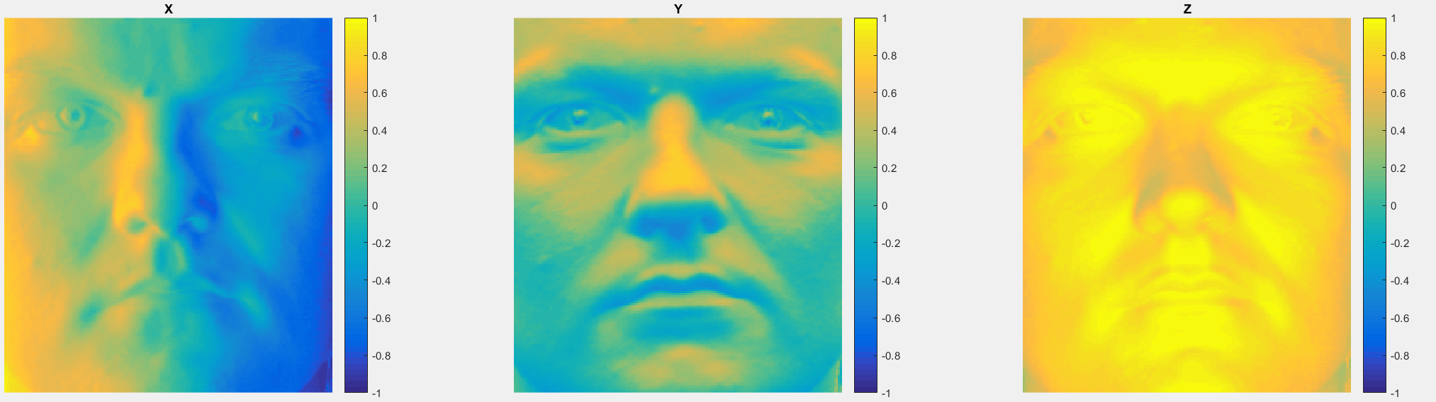

Average method:

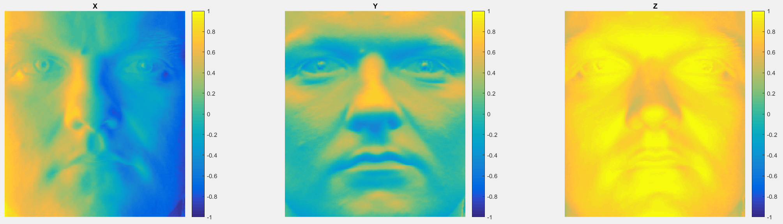

Random method:

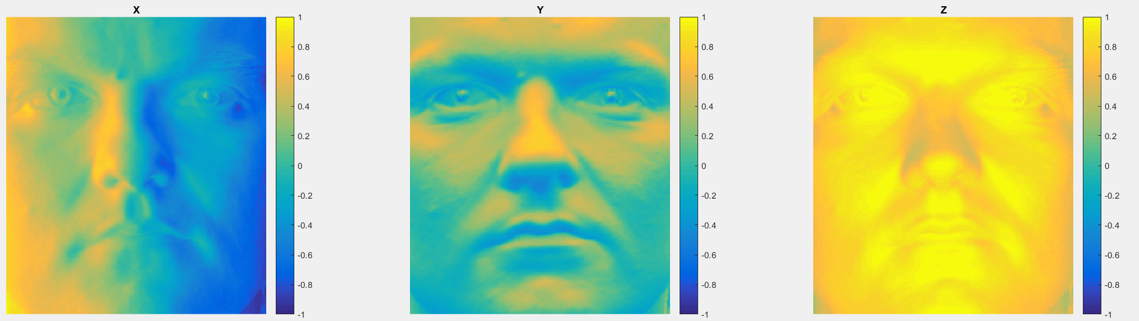

Subject: debug

Column method: 0.005479s Row method: 0.004242s

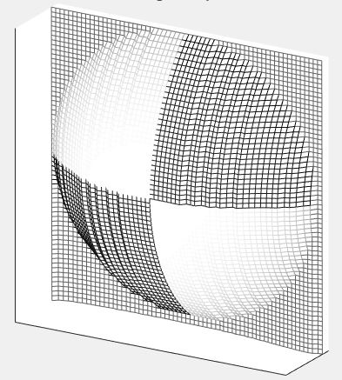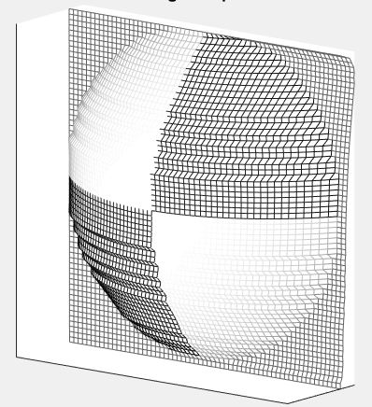

Average Method: 0.004524s Random method: 3.780084s

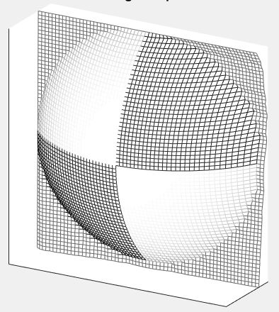

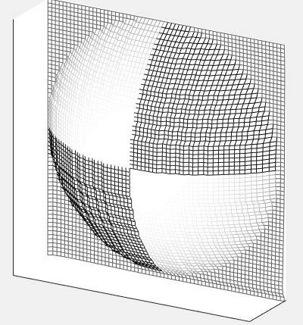

Albedo:

Comparison of the heightmap:

Column method:

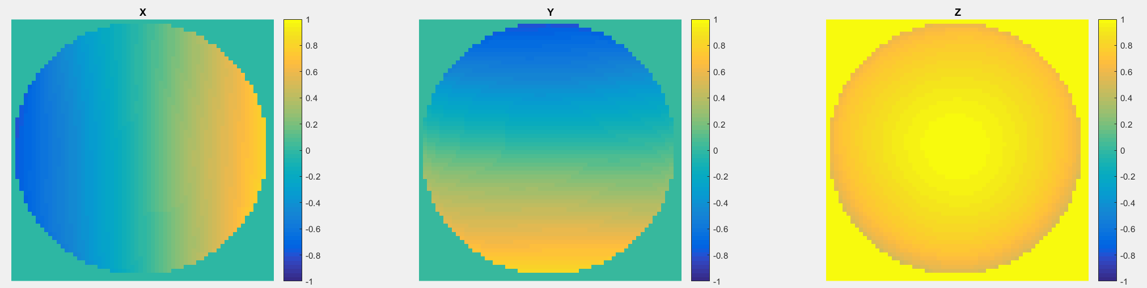

Row method:

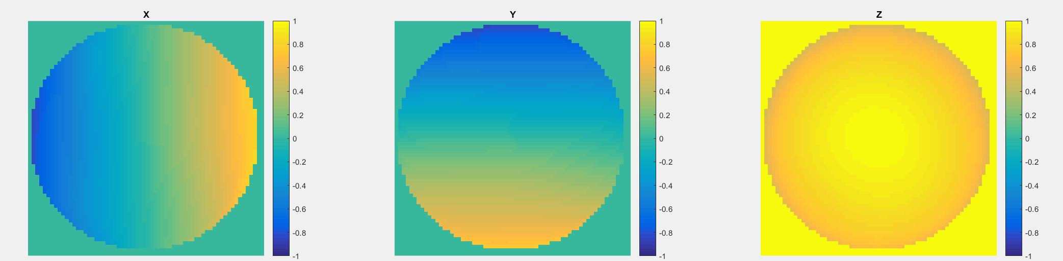

Average method:

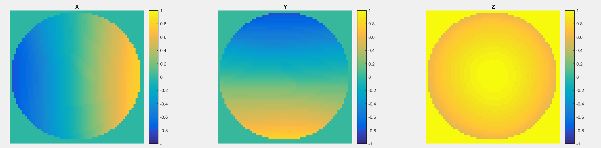

Random method:

